|  |  |  |  |
| --- | --- | --- | --- |
| Digicel eCommerce  Brandpath Change Request | | | |
| **Change Name** | Payment Processor Integration | | |
| **Change ID** | DIG_7_7_2106_CR | **Date Submitted** | July 7, 2016 |

**Version Control**

|  |  |  |  |  |
| --- | --- | --- | --- | --- |
| **Version** | **Status** | **Date** | **Author** | **Role** |
| 0.1 | Draft | 7 July 2016 | B Cerelli | Head of Sales |
|  |  |  |  |  |
|  |  |  |  |  |
|  |  |  |  |  |
|  |  |  |  |  |
|  |  |  |  |  |

**Stakeholders**

|  |  |  |
| --- | --- | --- |
| **Name** | **Company** | **Role** |
| Veronique Sotto | Digicel | Approver |
| Eugene O’Connor | Digicel | Approver |
| Ozkan Mustafa | Brandpath | Approver |
| Brigid Cerelli | Brandpath | Reviewer |
| Olivia Dodon | Brandpath | Reviewer |

**Change Request Summary**

Digicel requested a quotation for custom development in order to integrate with the Payment Processor – FAC .

Two options were discussed: direct API calls or a hosted FAC website which is a solution. **Approach**

In order to meet Digicel’s requirements of budget and time as well as complying with the strict Data Protection law of Bermuda Brandpath recommends redirecting to First Atlantic Commerce (FAC) :

* Backs off the PCI DSS responsibility to FAC
* FAC will manage and host the page which takes payment information and processes the Transaction
* Brandpath will make a commercial effort and do this for £5,000 budget

**Requirements**

To add a payment option to the Digicel Bermuda store which is currently non-transactional.

**Proposed Solution**

The hosted solution approach has been selected by Digicel. Brandpath will build and develop the hosted page on FAC using the design/look and feel of the current digicel Bermuda website. Once the customer has completed the personal details page they will be redirect to the payment pages hosted on FAC’s systems and complete all of the necessary payment steps whilst on the FAC website. Once the payment steps have been completed FAC will redirect back into the Digicel shop, providing a response code in the URL. If the payment has been successful the confirmation page will be displayed and details of the transaction will be submitted to Digicel via the Order SFTP files. If it has failed we will display a page with the error message.

The diagram below details the overall payment flow and transition from the digicel Bermuda shop onto the FAC hosted payment pages.

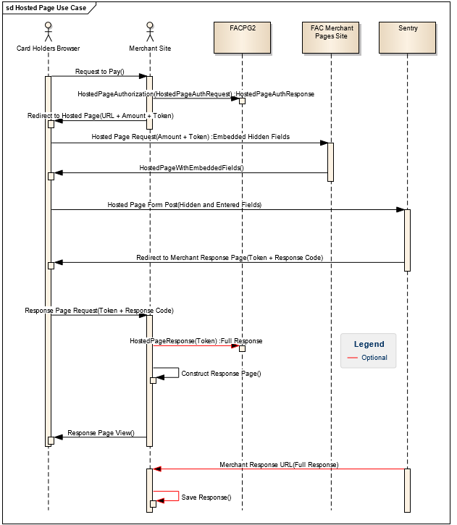

**Proposed Schedule**

|  |  |  |
| --- | --- | --- |
| **Task** | **Owner** | **Time** |
| Set Up FAC Test Platform | FAC | 1 |
| Design/Set Up of Hosted Page | Brandpath | 2 |
| Obtain a HPP security token (SingleUseToken) and Build Redirect URL | Brandpath | 1 |
| Confirmation Page Design | Brandpath | 1 |
| Confirmation Page Build | Brandpath | 1 |
| Response Code Integration with Confirmation Page | Brandpath | 1 |

**Test Plan**

Estimated at 2 days.

**RAID**

1. **X**

**Cost**

|  |  |  |  |
| --- | --- | --- | --- |
| **Resource** | **Day Rate£** | **Number of days** | **Total** |
| PM/BA | £478 (blended rate) | 1 | £478 |
| Sr Architect | £829 | 0.5 | £414.50 |
| Development | £595 | 6 | £3570 |
| Quality and Testing | £468 | 2 | £936 |
| **Total** |  | **9.5** | **£5,398.50** |

As discussed and agreed with Veronique, Brandpath will do the project for £4,859.50 (10% discount).